H D V T E S T I N G S I T E S
R E S O U R C E L I S T
MALI

HTTP://WWW.APROSADEV.ORG/

FACILITY NAME: ASSOCIATION POUR LA PROMOTION DE LA SANTE ET LE DEVELOPPEMENT ( APSAD)
ADDRESS: LAFIABOUGOU 460, PORTE 246
CITY: BAMAKO
TELEPHONE: 257-799-72501

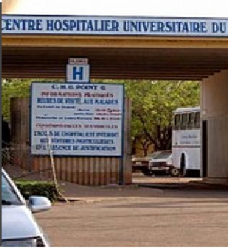

FACILITY NAME: CENTRE HOSPITALIER UNIVERSITAIRE DU POINTE
ADDRESS: KATI ROAD, BAMAKO, MALI
CITY: BAMAKO
TELEPHONE:


I F Y O U H A V E A D D I T I O N A L R E S O U R C E S T O S U G G E S T F O R T H E S E P A G E S , P L E A S E R E A C H O U T T O C O N N E C T @ H E P D C O N N E C T . O R G

